# Electrical Subsystem: Team SHUNYA IIT Bombay

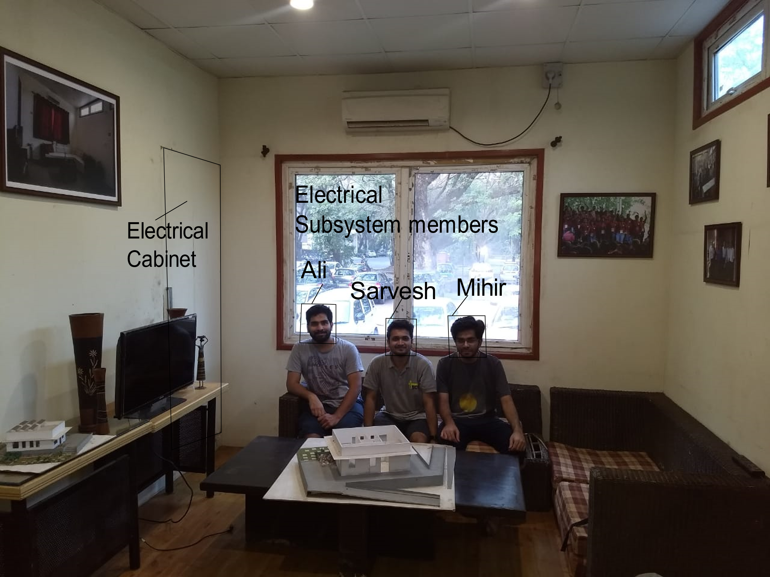

**Figure 1 Team SHUNYA Electrical Subsystem members**

## Short Description

Electrical Subsystem is responsible for electrical requirements of the house such as energy demands, wiring and home appliances. Aim of Electrical Subsystem is to achieve net positive energy status for the house while providing state of the art facilities. **Know More**

## Know more

Team SHUNYA relies on Electrical Subsystem to do following tasks.

1. Photovoltaics system and associated inverter design
2. Home Automation
3. Selection of Home Appliances
4. Design of Home Appliances (not readily available in market)
5. Electrical Wiring of the house

Electrical Subsystem is guided by Prof. B. G. Fernandes (HOD, Department of Electrical Engineering), Prof. Narendra Shiradkar (Department of Electrical Engineering) and Prof. Anupama Kowli (Department of Electrical Engineering). Faculty advisors provide mentorship and guidance to members. They provide feedback on work in progress and consultation throughout the operation.

## Skill required from subsystem members

The following skills are beneficial of the team member has them while joining. They should be imbibed if the team member lacks them while joining:

Software Skills: C/C++, Embedded coding, Eagle CAD, PVSYST, MATLAB

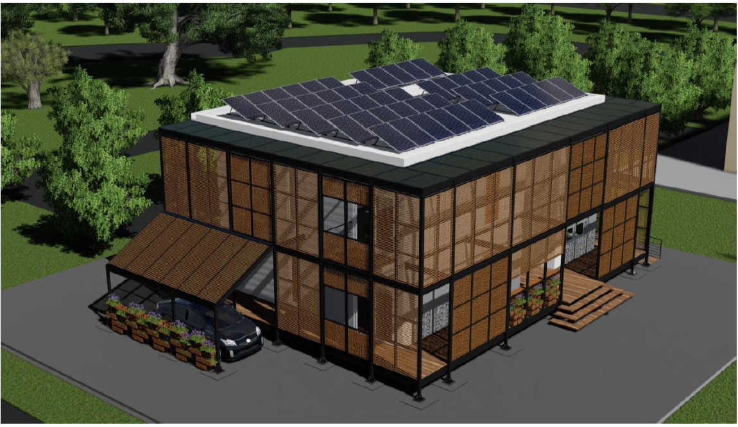

**Figure 2 Team SHUNYA 2018 House conceptualization with visible Solar Panels and E-Vehicle Parking and Charging Station**

## Team Members

1. Ali Asger Khattab

MTech PRA student, Department of Electrical Engineering

Email address: [ali.shunyaiitb@gmail.com](mailto:ali.shunyaiitb@gmail.com)

Personal Webpage: <https://www.ee.iitb.ac.in/course/~ali/>

1. Jasar Mohammed

BTech student, Department of Energy Science Engineering

Email address: [jasar.shunyaiitb@gmail.com](mailto:jasar.shunyaiitb@gmail.com)

1. Sarvesh Choudhri

MTech TA student, Department of Energy Science Engineering

Email address: [sarvesh.shunyaiitb@gmail.com](mailto:sarvesh.shunyaiitb@gmail.com)

1. Mihir Dhave

MTech TA student, Department of Energy Science Engineering

Email address: [mihir.shunyaiitb@gmail.com](mailto:mihir.shunyaiitb@gmail.com)